**Description of the amazon ecosystem**:

What merchants can influence through Sellics:

* inventory (setting how many items they keep in the warehouse)
* pricing (setting the price for each product)
* PPC management (setting how much they spend on each pair of keyword-product )
* organic keywords selection: pick up the keywords for which they would like to appear for each product
* listing editing: write product descriptions that maximize CTR and conversion rate

PPC = Pay Per Click = paid traffic

CTR = Click Through Rate = Clicks / Impressions  
Impression = appearance of the ad on the page. Note: the ad may appear below the fold (ie: the user has to scroll down to see it, so impressions <= views)

Organic ranking for a given pair of “keyword + product” is influenced by:

* shopper satisfaction: conversion rate, reviews, delivery time, CTR...
* revenue generated: revenue/conv, conv rate, clicks

Note: the merchant chooses the keywords for which they want to try and rank organically. Then whether the product actually shows or not is determined by Amazon.

Paid search orders influence the organic ranking: if, for a given keyword, a product receives some sales, it is seen by amazon as a sign that this product is relevant for that keyword, and this product gets a better organic ranking for said keyword

Pricing influences:

* organic ranking through its impact on CTR, reviews, conv rate, order volume, and revenue.
* paid traffic acquisition through its impact on rev/click
* rate of returns (as low prices are associated with lower return rates)

PPC management aims at buying traffic from the right keywords at the right cost to maximize revenue generated for a given budget. Part of PPC management is also determining the ideal amount of spend to maximize the end profit

Listing = description (pictures, video, headline, key characteristics of the product).

* Some elements of the listing (headline, 1st picture, prime batch) increase the CTR and therefore the organic ranking.
* The listing also influences the conversion rate (for eg. the presence of a video tends to boost it).

Note: When a product has “prime batch”, it means that prime members do not pay shipping. Shipping cost is not included in the price displayed in the listing. 50% of amazon users are prime members.

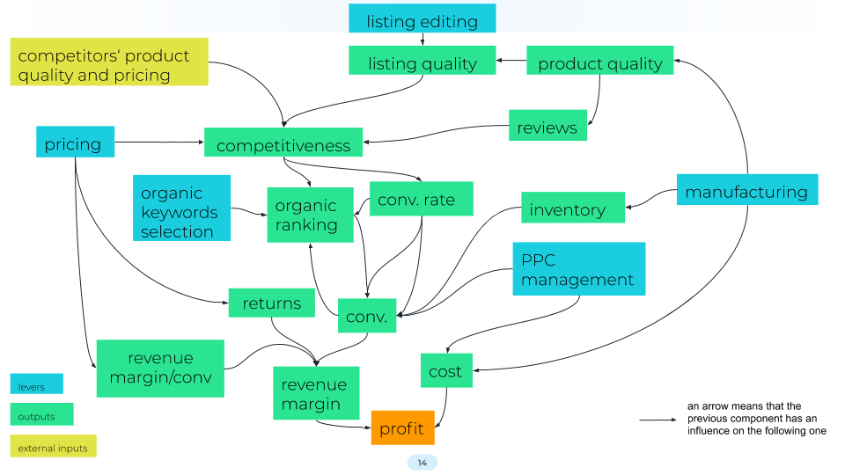

The global objective is to maximize long term profit for a merchant

Several components are interacting: a change to any component implies latent interactions impacting the global objective, we have hundreds or more variances

Ideal models shall tell us the impact of a change on the profit and make a recommendation for each parameter

**Question:**

What are your thoughts on this ecosystem and how Sellics can use Machine Learning to allow merchants to maximize their profit on Amazon?